URL : http://cooltoolsforschools.wikispaces.com/Home
This site provides teachers a list of online educational tools categorized as to their usage….

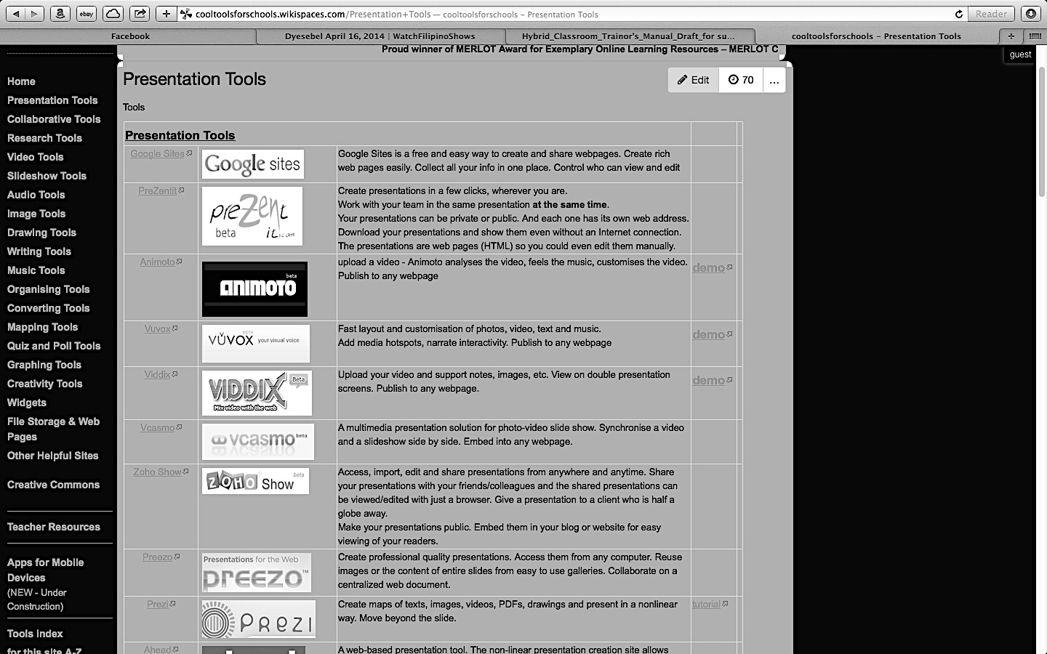

Click on any of the text at this side and the website will give you a list of online educational tools that you can use for that specific purpose…

Hundreds of online educational tools can be accessed through this site!

