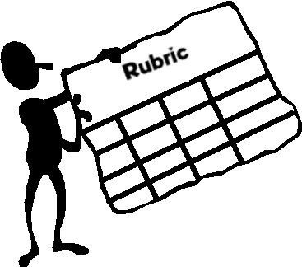
Performance is most often viewed in the form of formative and summative assessment. Formative assessment is ongoing and provides information needed to adjust teaching and learning. It not only helps to monitor student progress throughout an activity, but can also gauge student understanding and readiness to proceed to further tasks. Summative assessment focuses on a particular point in time-- often at the conclusion of an activity. Both types of assessments are valuable tools when designing tasks to demonstrate mastery or understanding.
Providing detailed explanations of an assignment using a rubric can assist students in both completing the tasks and improving future performance.

Rubrics for a particular project are available for downloaded from the following links :

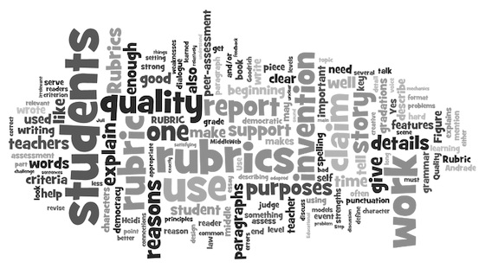
https://www.uwstout.edu/soe/profdev/rubrics.cfm#oral

http://teamcproject.wikispaces.com/The+Assessments

http://www.teach-nology.com/gold/rubricsets.html

http://www.rubrics4teachers.com

You can also create your own rubrics using the links below :

http://rubistar.4teachers.org
Registered users can save and edit rubrics online. You can access them from home, school, or on the road. Registration and use of this tool is free, so click the Register link in the login area to the right to get started now.

http://www.teach-nology.com/web_tools/rubrics/project/
This generator can be used to help you assess student projects. The rubric includes the assessment of both the process used for the project and the assessment of the final product.

