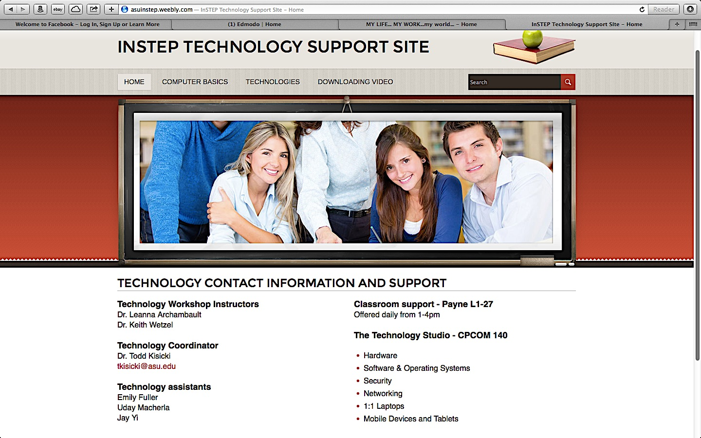
This INSTEP TECHNOLOGY SUPPORT SITE created in Weebly provides all the necessary support for a successful lesson integrated with technology. It can be accessed through this URL : www.asuinstep.weebly.com .
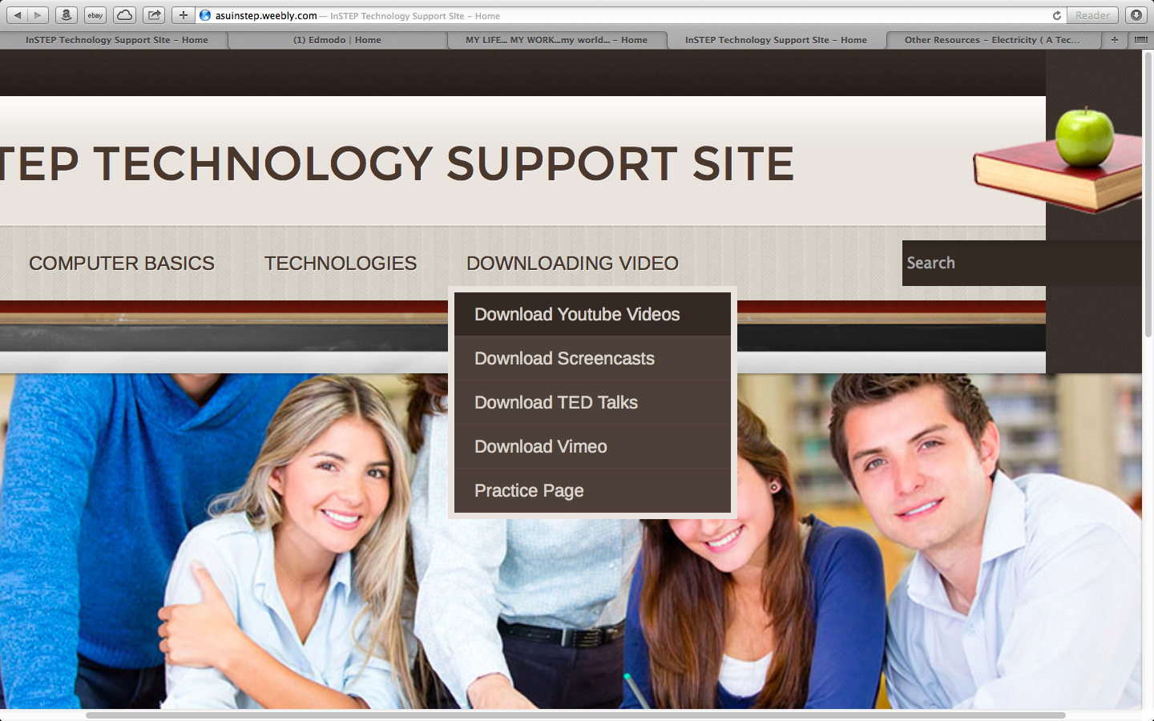

Most of the sites are linked to other useful information….

Video tutorials….

A step-by-step printable instructions in pdf format…

Downloadable screencasts…
