Domain and Range of a Function Quiz
1. The domain of the function is the set of all possible values for the independent variable.
- $True$
- $False$
2. The domain for this function: $f\left(x\right)=\frac{1}{x+1}$ is all real numbers except $x≠1$.
- $True$
- $False$
3. Identify the domain and range for $f\left(x\right)=2x+4$
- $Domain:\left\{all real numbers\right\} Range:\{all real numbers\}$
- $Domain:\left\{positive real numbers\right\} Range:\{positive real numbers\}$
- $Domain:\left\{0, 1, 2, 3, 4\right\} Range:\{4, 6, 8, 10, 12\}$
- None of the above
4. Find the range for the given function $f\left(x\right)=x^{3}$when the domain is 0, 1, 2, and 3.
- $Range:\{0, 1, 2, 3\}$
- $Range:\{0, 1, 4, 9\}$
- $Range:\{0, 3, 6, 9\}$
- $Range:\{0, 1, 8, 27\}$

5. Eli makes $20 an hour tutoring math. The number of hours Eli works would be the range of the function.
- $True$
- $False$
6. The range for this function: $f\left(x\right)=x^{2}+2$, would be:
- $Range:\{all real numbers\}$
- $Range:\{f(x)≤0\}$
- $Range:\{f(x)≥0\}$
- none of the above
For the next two questions, use the graph displayed below to find your answer.
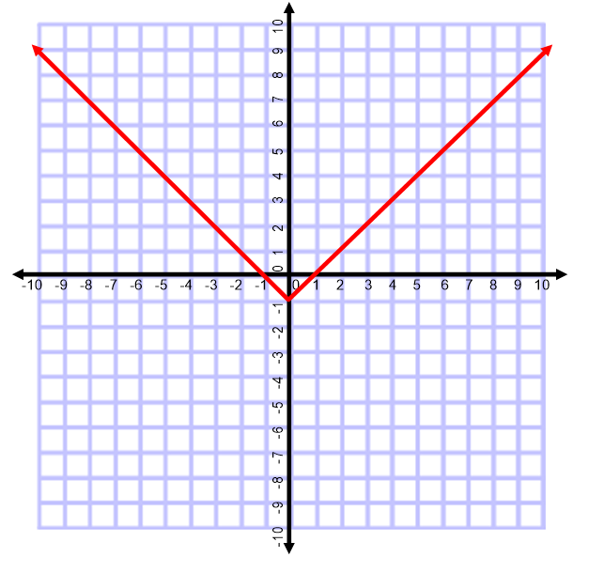
7. Which of the following correctly identifies the domain of the function in the graph above?
- $Domain:\{all positive real number\}$
- $Domain:\left\{all negative real number\right\}$
- $Domain:\left\{all real number\right\}$
- $Domain:\left\{y≥-1\right\}$
8. Which of the following correctly identifies the range of the function in the graph above?
- $Range:\{all positive real number\}$
- $Range:\left\{all negative real number\right\}$
- $Range:\left\{all real number\right\}$
- $Range:\left\{y≥-1\right\}$
9. Jill earns $15 for each hour worked at the market. The market set a limit for her work hours to be a maximum of 20 hours a week. For this type of situation, identify the domain of the function for the number of hours worked in a week.
- $Domain:\{all positive real number\}$
- $Domain:\left\{15≤x≤300\right\}$
- $Domain:\left\{x≥15\right\}$
- $Domain:\left\{0≤x≤20\right\}$

