Domain and Range of a Function Quiz Demo
1. The domain of the function is the set of all possible value for the independent variable.
Answer
a) True
Demo
Refer to:
http://www.ck12.org/algebra/Domain-and-Range-of-a-Function/lesson/Domain-and-Range-of-a-Function/
“The set of all possible input values for the independent variable is called the domain.”
The statement is true.
2. The domain for this function: $f\left(x\right)=\frac{1}{x+1}$ is all real number except $x≠1$.
Answer
b) False
Demo
$$f\left(x\right)=\frac{1}{x+1}$$
$$x+1≠0$$
$$x≠-1$$
The statement is false. The domain is all real number except $x≠-1.$
3. Identify the domain and range for $f\left(x\right)=2x+4$
Answer
a) $Domain:\left\{all real numbers\right\} Range:\{all real numbers\}$
Demo
$$f\left(x\right)=2x+4$$
All real number are possible for both domain and range.
4. Find the range for the given function $f\left(x\right)=x^{3}$when the domain is 0, 1, 2, and 3.
Answer
d) $Range:\{0, 1, 8, 27\}$
Demo
$$x$$ | $$f\left(x\right)=x^{3}$$ | $$y$$
$$0$$ | $$f\left(0\right)=0^{3}$$ | $$0$$
$$1$$ | $$f\left(1\right)=1^{3}$$ | 1
$$2$$ | $$f\left(2\right)=2^{3}$$ | 8
$$3$$ | $$f\left(3\right)=3^{3}$$ | 27
$$Range:\{0, 1, 8, 27\}$$

5. Eli makes $20 an hour tutoring math. The number of hours Eli work would be the range of the function.
Answer
b) False
Demo
The number of hours Eli work would be the domain of the function.

6. The range for this function: $f\left(x\right)=x^{2}+2$, would be:
Answer
d) none of the above
Demo
The range for this function$f\left(x\right)=x^{2}+2$, would be $Range:\left\{y≥2\right\}$

For the next two questions, use the graph displayed below to find your answer.
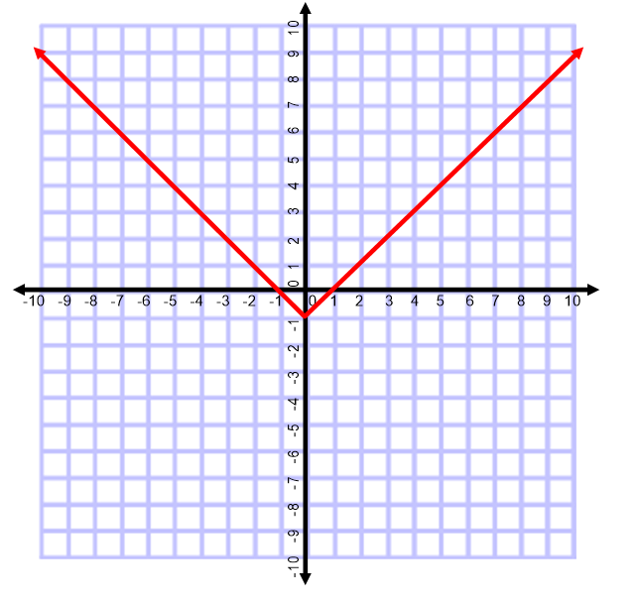
7. Which of the following correctly identify the domain of the function in the graph above?
Answer
c) $Domain:\left\{all real number\right\}$
Demo
All real numbers can be used/seen in the graph for x-coordinates (domain).
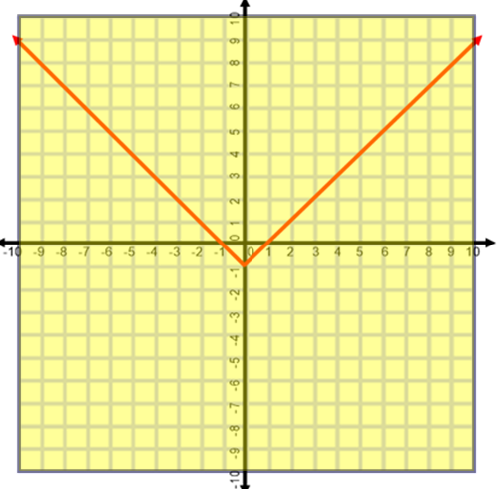

8. Which of the following correctly identify the range of the function in the graph above?
Answer
d) $Range:\left\{y≥-1\right\}$
Demo
The graph shows the lowest points reach $y=-1$and moves upwards in both directions. The range is $y≥-1$ as indicated in the highlighted section of the graph.
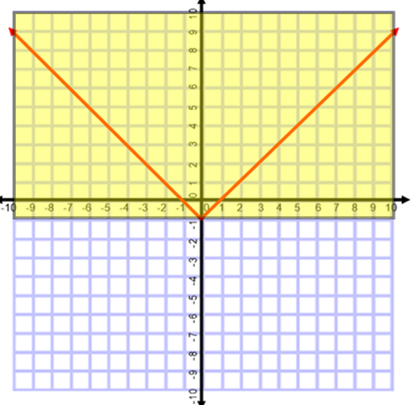
9. Jill earn $15 each hour worked at the market. The market set a limit for her work hours to be a maximum of 20 hours a week. For this type of situation, identify the domain of the function for the number of hours worked in a week.
Answer
d) $Domain:\left\{0≤x≤20\right\}$
Demo
Jill can work zero hour to a maximum of 20 hours a week.
$$Domain:\left\{0≤x≤20\right\}$$

