PACKETS FOR DIGITAL TOOLS

How to Download Popplet as handout.

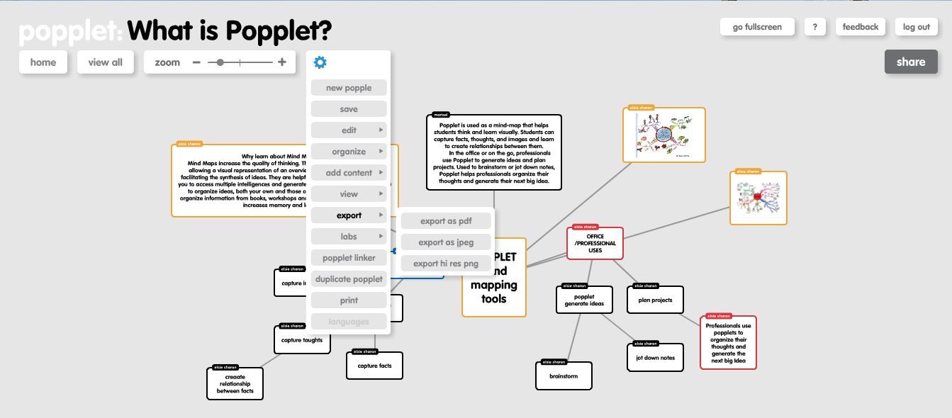

Go to setting click on export and choose export as pdf. The popplet will be safe in the laptop as
a pdf file.

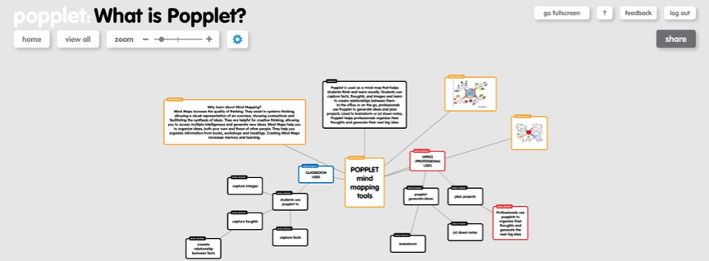
Uses of Popplet.

HOW TO DOWNLOAD PHET VIDEO.

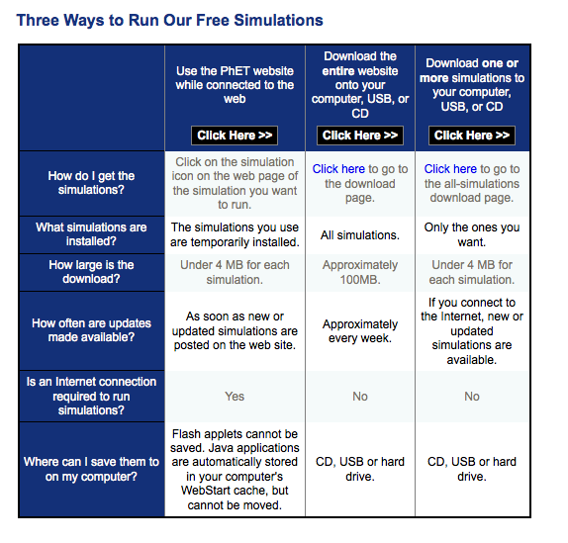
http://phet.colorado.edu/en/get-phet

PADLET (Wallwisher) is a fantastic little web application that provides a virtual bulletin board of sorts. Teachers can pose questions or ideas for students to answer or think about. Students are sent the unique wall URL and can leave virtual sticky notes answering the question. Students do not have to login to use Padlet, a simple double click allows them to add any thoughts they need to the wall. The platform is very simple to use but provides the opportunity for discussion and collaboration between students.

How to integrate Padlet into the classroom:
a. Padlet can be used to create a flexible online space where students can create virtual posters, brainstorming boards, virtual project portfolios, and share learning with others. Students can work together on the same Padlet space for group projects.

b. Padlet offers an exceptional opportunity for students to brainstorm, collaborate, and group ideas. Students can use Padlet to brainstorm ideas for writing, explore lines of inquiry, collect research, for grouping ideas, and collaborating on group projects. Create a Padlet board for your students and ask them to group like ideas, sort, and expand on thoughts. This could be done for any historical event, literature, science concept, and even phonics. Students could practice spelling by typing out their spelling words along with a sentence or synonyms on sticky notes. Then, they can group words by spelling pattern or common phoneme blends.

c. Create a Padlet of sticky notes with English words and sticky notes with a foreign language word on them. Students can work together to group words with their meanings.

d. In math, create Padlet stickys with word problems on one color of sticky note and answers on another set of sticky notes. Students can work to create groups of problems and their solutions. Padlet can be used for whole class activities using an interactive whiteboard, the class can brainstorm together and collect ideas or use the grouping feature in an activity created by the teacher or students.

e. Students could even use Padlet to create “bucket lists.” They could create a bucket list of books they would like to read, places they would like to travel, imaginary literary places they would like to travel, things they want to learn about, etc.

f. Padlet boards are SO versatile. If you need a way for students/teachers/parents to collaborate digitally, Padlet is the place. Now that boards can be downloaded and printed…the possibilities for use are even greater!

TO PRINT OR DOWNLOAD:
a. Now you can take all of your Padlet walls and save them as an image, PDF, Excel or CSV format. Just click the share/export button and you are in business!
b. Another fun new feature is the ability to keep up with what has been posted to your digital wall using email notifications. You can sign up to get a daily update of all activity on the wall.

http://ewallstreeter.com/padlet-now-with-the-ability-to-download-and-print-4751/

Prezi
Prezi offers a non-linear, visually oriented, and easy to learn platform for your multimedia presentations. It allows you to have all your information in one place, and liberates you from traditional narrative structures as you navigate through it. In other words, you can maneuver your information and make comparisons without having to go back and forth through numerous slides, which adds a degree of fluidity and continuity to your delivery. You can guide your audience through your desired points by focusing on specifics, but they can also literally see "the big picture." And it gives you the ability to easily manipulate your information in response to spontaneous conversation.
Your project will be laid out as a sort of conceptual and visual "mind map," offering flexibility in its layout and organization as well as in its presentation. Prezi lends itself well to certain thought processes and content, and is particularly useful for sharing high resolution photographic images; you can zoom in and out of pictures to view details.
In some senses Prezi requires a little more design effort than, say, PowerPoint. But it doesn't need to be complicated, and it permits you much more freedom in how you show your information. So give it a try!
After logging into the Prezi website, simply click the "New Prezi" button. You will be asked to choose a template, and though you'll probably want the "blank" one, the others will provide you with a number of readymade elements you can customize as desired once you're familiar with prezi's tools.
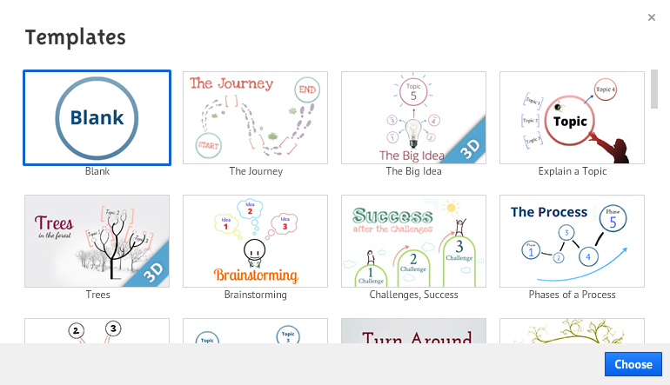
Make your selection and you're ready to go!

Getting Started
The tools for adding to your Prezi are located at the top of the screen.
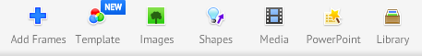
You may choose to switch frequently between "write" mode, in which you can edit your presentation, and "present" mode, in which you can test it out. You can do this by clicking the "present" button in the upper left-hand corner of your workspace, and using the "escape" button on your keyboard to return to editing.
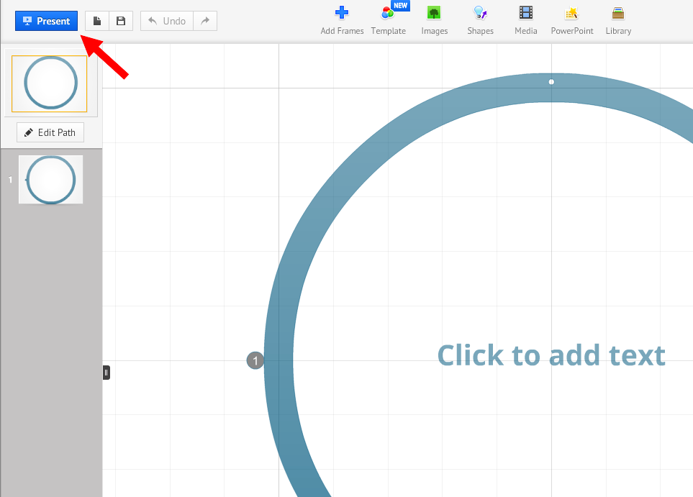
While you are working on your presentation, you can move the visible area of your workspace by clicking, holding, and dragging your mouse. If your mouse has a scroll wheel, you can use it to zoom in and out of your workspace. If not, you can use the magnifying glass icons in the tool on the right-hand side of your screen.
Click on the magnifying glass buttons to zoom into or out of your workspace. You can easily maneuver to a full view of your active canvas by clicking on the "home" button at the top of your zoom tool.
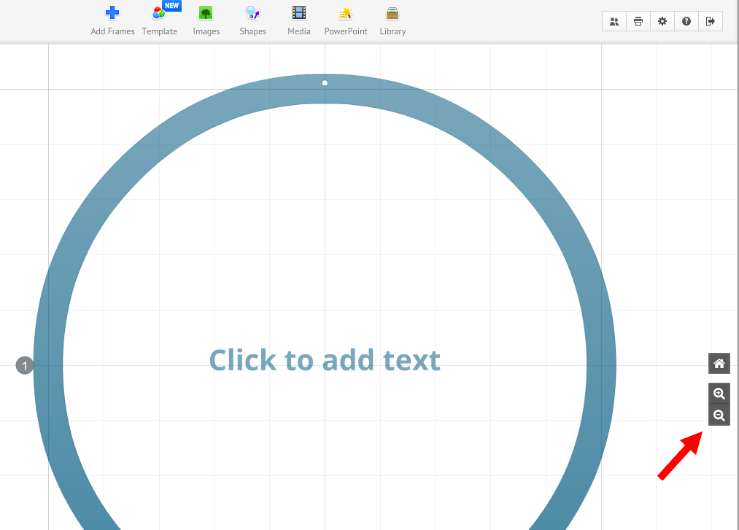

Alternatively, you can select the rectangular box shown at the top of the sidebar to return "home."
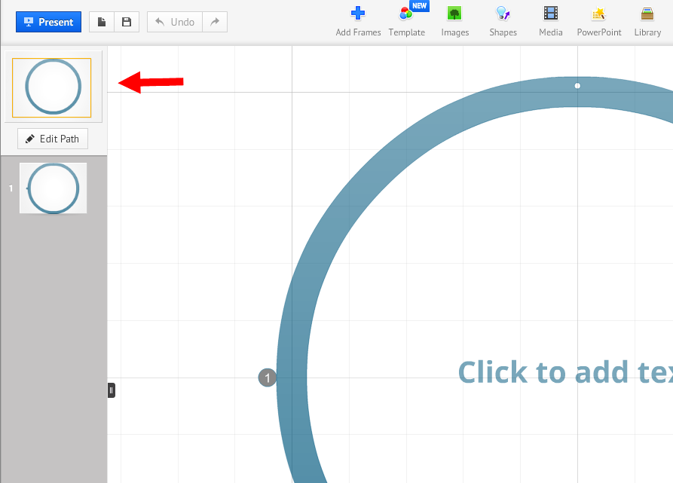
Once you are in this "home view," you should be able to mouse over and click on individual elements to zoom right into them. However, note that this feature seems only to work if your elements are of a certain size relative to your active workspace, or are at least surrounded by frames of "acceptable" dimensions).
Check out a few examples of the videos posted in the Prezi Showcase to get a sense of the opportunities it affords. Using Prezi is very intuitive once you gain a level of familiarity with the format and basic tools. We've provided a series of how-to pages below to help you get on your way.
More Detailed How-Tos on How to Make A Prezi
· Add shapes: augment your presentation with arrows, lines, and highlights
· Add frames: utilize this tool to further organize your presentation
· Create a path: program a sequence for your presentation to follow
· Customize colors and appearance: choose from preset themes or customize color options
· Group Editing: set up group editing for a prezi project
· Play your prezi: review your project and prepare it for presenting

http://dml.wikis.bgc.bard.edu/prezi-how-to

HapYak Interactive Video

No matter how you use video, interactive video is more effective. With HapYak, people engage more and watch longer.
HapYak makes it easy to make video interactive with simple tools and services that are seamlessly integrated with Video Cloud.
Add video quizzes, chapters, synchronized text and image overlays, links and even drawings directly on top of your videos using simple web tools. Allow viewers to register, download, sign-up, go to any page on your website or share their knowledge directly from the video.
HapYak is HTML5 and CSS-based so the look and feel is completely customizable. We're always amazed at how people use interactivity to transform their videos.
If you can watch a video, you can make it interactive. Try it out today and see!

FEATURES & BENEFITS
Features
· Simple web tools so non-experts can create interactive videos
· Video Quiz with optional LMS integration
· Video Chapters
· Links in Video
· Draw on Video
Benefits
· Get viewers to click and to interact with your videos
· Interactive features create true, measurable engagement analytics
· People engage more
· People watch longer
· Provide contextual, relevant, synchronized information that adds value for the viewer
· Quick ROI: Make your existing videos work harder and produce the outcomes you care about

INTEGRATION OVERVIEW
1. Click here to go to the interactive demo: http://corp.hapyak.com/partners/brightcove/.
2. Get a free trial license by contacting info@hapyak.com. HapYak will email you a link to your personalized HapYak tool for Brightcove.
3. Click on your personalized link and paste in the link or embed code of the Brightcove video you want to make interactive. Use the HapYak toolbar to add your interactive elements.
4. Copy the new embed code and paste it anywhere.
5. Contact info@hapyak.com to get an official license.

http://www.brightcove.com/en/partners/hapyak-interactive-video

HOW TO DO SCREENSHOTS?

FOR WINDOWS
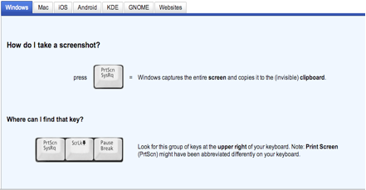

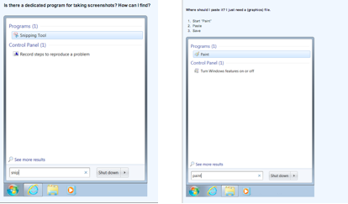
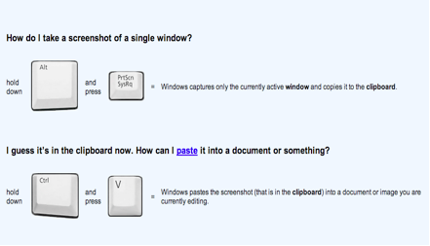
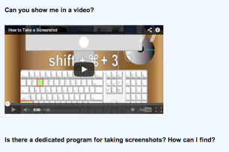
https://www.youtube.com/watch?v=EoTpIYLBtKs#t=13

FOR MAC
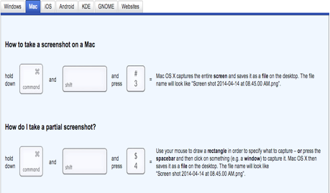

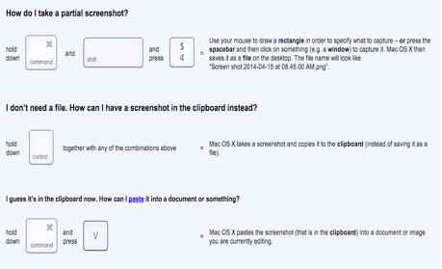
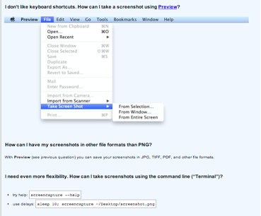

http://www.take-a-screenshot.org/

